**Project Design Phase-II**

**Technology Stack (Architecture & Stack)**

|  |  |
| --- | --- |
| Date | 03 October 2022 |
| Team ID | PNT2022TMID47104 |
| Project Name | Project –Inventory Management System for Retailers |
| Maximum Marks | 4 Marks |

**Technical Architecture:**

The Deliverable shall include the architectural diagram as below and the information as per the table1 & table 2

**Example: Order processing during pandemics for offline mode**

**Reference:** [**https://developer.ibm.com/patterns/ai-powered-backend-system-for-order-processing-during-pandemics/**](https://developer.ibm.com/patterns/ai-powered-backend-system-for-order-processing-during-pandemics/)

Guidelines:

1. Include all the processes (As an application logic / Technology Block)
2. Provide infrastructural demarcation (Local / Cloud)
3. Indicate external interfaces (third party API’s etc.)
4. Indicate Data Storage components / services
5. Indicate interface to machine learning models (if applicable)

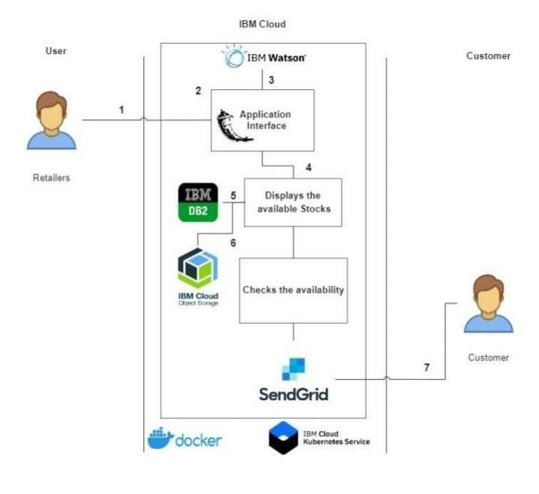

**Table-1 : Components & Technologies:**

|  |  |  |  |
| --- | --- | --- | --- |
| **S.No** | **Component** | **Description** | **Technology** |
|  | User Interface | Web developers interacts with application e.g.  Web UI, Mobile App, Chatbot etc. | HTML, CSS, JavaScript / Angular Js / React Js etc. |
|  | Application Logic-1 | Java is a faster language,Python is simpler and easier to learn | Java / Python |
|  | Application Logic-2 | Enables fast and accurate speech transcription in multiple languages for a variety of use cases | IBM Watson STT service |
|  | Application Logic-3 | Build conversational interfaces into any application, device,or channel | IBM Watson Assistant |
|  | Database | Data Type, Configurations etc. | MySQL, NoSQL, etc. |
|  | Cloud Database | Database Service on Cloud | IBM DB2, IBM Cloudant etc. |
|  | File Storage | New Technology File System(NTFS), File Allocation Table(FAT) | IBM Block Storage or Other Storage Service or Local Filesystem |
|  | External API-1 | Actionable,dependable,and accurate weather forecasts | IBM Weather API, etc. |
|  | External API-2 | Simple API with a call and retrieve function | Aadhar API, etc. |
|  | Machine Learning Model | Convolutional neuralnetworks, or CNNs | Object Recognition Model, etc. |
|  | Infrastructure (Server / Cloud) | Application Deployment on Local System / Cloud  Local Server Configuration:Open server , Denwer , Winginx,XAMPP  Cloud Server Configuration : HTTP resource-based API for external configuration | Local, Cloud Foundry, Kubernetes, etc. |

**Table-2: Application Characteristics:**

| **S.No** | **Characteristics** | **Description** | **Technology** |
| --- | --- | --- | --- |
|  | Open-Source Frameworks | Template for software development that is a designed by a social network of software developers | Source code is freely available to use,modify,and redistribute |
|  | Security Implementations | Security policy,Internet of things,Transport layer security,Program management / access controls implemented, use of firewalls etc. | e.g. SHA-256, Encryptions, IAM Controls, OWASP etc. |
|  | Scalable Architecture | Supports higher workloads without any fundamental changes to it (3 – tier, Micro-services) | Software as a service applications(SaaS) |
|  | Availability | Quality or state of being available (e.g. use of load balancers, distributed servers etc.) | Computer acess and internet connectivity for the technology |
|  | Performance | Design consideration for the performance of the application (number of requests per sec, use of Cache, use of CDN’s) etc. | Cloud management, Application performance monitoring(APM) |

**References:**

[**https://c4model.com/**](https://c4model.com/)

[**https://developer.ibm.com/patterns/online-order-processing-system-during-pandemic/**](https://developer.ibm.com/patterns/online-order-processing-system-during-pandemic/)

[**https://www.ibm.com/cloud/architecture**](https://www.ibm.com/cloud/architecture)

[**https://aws.amazon.com/architecture**](https://aws.amazon.com/architecture)

[**https://medium.com/the-internal-startup/how-to-draw-useful-technical-architecture-diagrams-2d20c9fda90d**](https://medium.com/the-internal-startup/how-to-draw-useful-technical-architecture-diagrams-2d20c9fda90d)